Department of Computer Science and Engineering
2025-2026
Odd Semester


DATA STRUCTURES AND ALGORITHMS-3
(25CS2103E)

LAB MATCH ALLOCATOR

P. MANISHA 2520030054
P. RENUKA CHOWDARY 2520030176
U. SRILAXMI 2520030272

COURSE INSTRUCTOR

Dr. J Sirisha Devi
Professor
Department of Computer Science and Engineering
LAB MATCH ALLOCATOR

Lab Match Allocator is a Data Structures and Algorithms (DSA) based project designed to efficiently allocate students to laboratory sessions according to their preferences and available lab capacities. The project uses the Bipartite Matching algorithm to create an optimal relationship between students and laboratories.
In this system, students and laboratories are represented as two separate sets of vertices in a bipartite graph. An edge is created between a student and a lab when that student is eligible or interested in that particular lab. The bipartite matching algorithm then finds a suitable allocation where each student is assigned to at most one laboratory and each laboratory receives students according to its available capacity.
Main Features
- Students can provide their preferred laboratories.
- Laboratories have limited available seats.
- The system creates a bipartite graph between students and labs.
- Bipartite matching is used to allocate students efficiently.
- The system identifies students who could not be allocated a lab.
- It reduces manual allocation and avoids duplicate assignments.
- The allocation results can be displayed clearly for students and administrators.
Example
Suppose there are 4 students and 3 laboratories:
- Student 1 → C Programming, IoT Lab
- Student 2 → IoT Lab, DBMS Lab
- Student 3 → DBMS Lab
- Student 4 → C Programming, DBMS Lab
The system creates connections based on these preferences and applies bipartite matching to produce an allocation such as:
Student 1 → IoT Lab
Student 2 → DBMS Lab
Student 3 → DBMS Lab
Student 4 → C Programming Lab
Thus, Lab Match Allocator demonstrates the practical application of graphs, bipartite matching, queues/arrays, and algorithmic problem solving to solve a real-world resource allocation problem.

DSA Concepts Used
Our project mainly focuses on the following DSA concepts:
- Graph
- Bipartite Graph
- Bipartite Matching
- Arrays / Lists
- Graph Traversal
- Searching
- Algorithmic Optimization
- Time and Space Complexity

ALGORITHM / PSEUDO CODE

Algorithm
- Start the Lab Match Allocator.
- Read the number of students and laboratories.
- Enter student preferences and laboratory capacities.
- Create a bipartite graph where:
  - Students form one set.
  - Laboratories form another set.
  - An edge represents a student's preference for a laboratory.
- Initialize all laboratories as unassigned.
- For each student, check their preferred laboratories.
- If a laboratory has an available seat, assign the student.
- If the laboratory is occupied, try to move the existing student to another suitable laboratory using an augmenting path.
- If no suitable laboratory is found, mark the student as unallocated.
- Display the final student-laboratory allocation.
Pseudocode
START

Read students and laboratories
Read student preferences
Read laboratory capacities

Create bipartite graph

FOR each student
Mark all laboratories as unvisited

FOR each preferred laboratory
IF laboratory has free seat
Assign student to laboratory
BREAK
ELSE
Try to reassign the existing student
END IF
END FOR

IF no laboratory is found
Mark student as unallocated
END IF
END FOR

Display final allocation
Display unallocated students

STOP
Example
Student 1 → IoT Lab
Student 2 → DBMS Lab
Student 3 → Programming Lab
Thus, the Lab Match Allocator uses Bipartite Matching to allocate students efficiently according to their preferences and available laboratory seats.

CODE

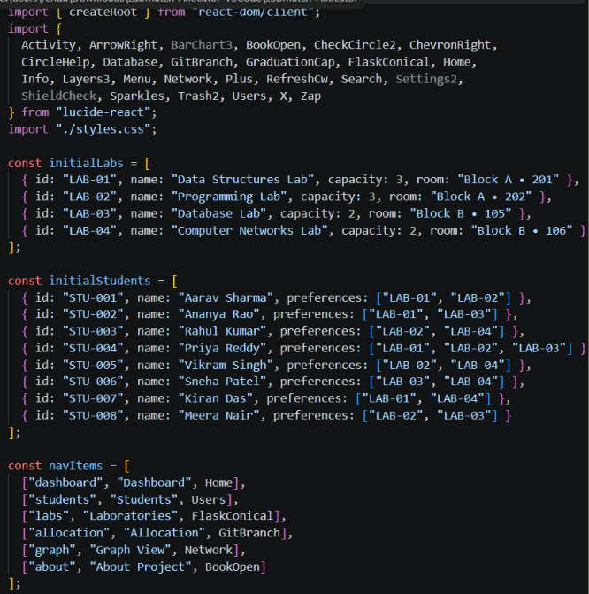

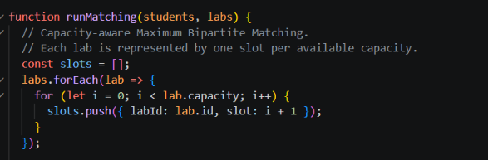

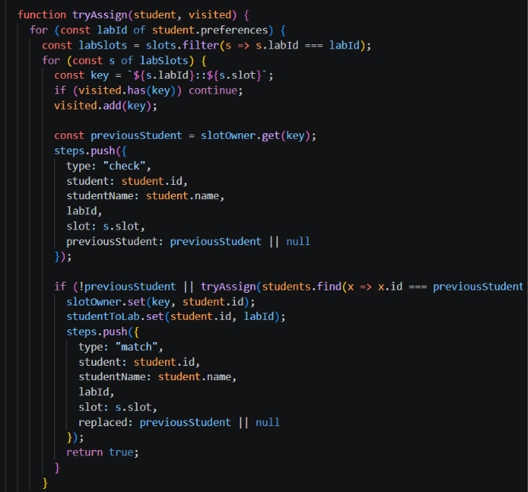
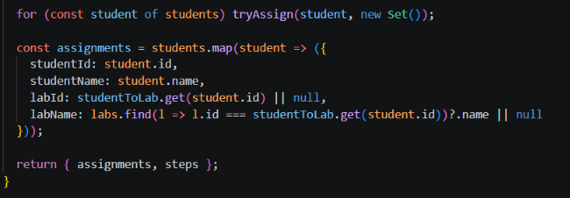
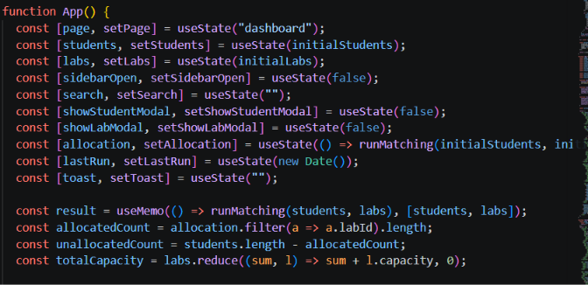

RESULTS

